

**Software Engineering Analysis and Design**

**ReceptionApp**

**Members**

Joan Lushi

Denis Zanaj

Eduard Bajo

**Table of Contents**

1. EXECUTIVE SUMMARY

PROJECT OVERVIEW

PURPOSE AND SCOPE OF THE SPECIFICATION

* PRODUCT/SERVICE DESCRIPTION………………………………………….
  1. PRODUCT CONTEXT………………………………………………………………………...
  2. USER CHARACTERISTICS………………………………………………………………….
  3. ASSUMPTIONS…………………………………………………………………………
  4. CONSTRAINTS…………………………………………………………………………
  5. DEPENDENCIES………………………………………………………………………
* REQUIREMENTS………………………………………………………………
  1. FUNCTIONAL REQUIREMENTS……………………………………………………………
  2. NON-FUNCTIONAL REQUIREMENTS………………………………………………
     1. PRODUCT REQUIREMENTS……………………………………………….......
     2. ORGANIZATIONAL REQUIREMENTS……………………………………
     3. EXTERNAL REQUIREMENTS…………………………………………………

**Product Overview**

ReceptoinApp is an application that can keep track of all the procedures needed for a company to hire new staff, make sure that their work is in check, to ensure that everything is being done correctly, and that all needed documents are kept in check. This application will help in multiple departments, so that they are also informed of everything that is going on inside the company.

This application also seeks to help the employees of a company, so that they can also be well informed of the hours that they have spent working, and also the full amount that they are to be paid on their pay day, this will also be helpful to the finance department, as a bonus, since they can also skip the process of making the calculations for each employee.

Until now, most CV's and documents are usually sent via email, making it a bit of a chore for most Human Resources workers, while with ReceptionApp, everything will be sent in on the portal, so there will be no need to have them printed out and stored.

For this reason, and many more, our group has decided to create ReceptionApp, which will make keeping track of employees, and hiring new ones, as easy as it can get.

Purpose and Scope of Specifications

The main purpose of ReceptionApp is to make it easier to hire new staff, make it easier for communication between different departments since only the needed information will be able to be transmitted, and to also have transparency between companies and their employees.

This application will have different uses base on which person uses it.

**Product/Service Description**

ReceptionApp is a web application software that aims to create a better work environment for all workers of any company. Through this software, different departments can make requests of new staff that is needed, and also keep trac of all the existing staff. This way companies can manage and observe employees better, but employees can also be more informed of everything related to them. This system can be used by all members of the company, with specific levels of access for each one.

**Product Context**

This product is intended to be used by all members of the firm. Everyone will be able to have access to any needed information much easier and departments will have better communication with each other.

**User Characteristics**

All members of the company will be using this system, which means that there will be different levels of access for everyone.

The Super Admin, they will have access to everything, they will also be able to grant access to different people based on which line of work they are in.

The Human Recourses worker will be able to access the employee's details, their own and also to communicate with other departments.

The Finance department worker will have access to the employees details, so that they can access their bank details, and the hours that they have worked with the ammount that they are to be paid, their own information and a mean to contact the other departments.

The employee will be able to only see their own details, hours that they have worked and the ammount that they are expected to earn based on that, and to also have a means to communicate with other departments.

**Assumptions**

-The system is expected to have access to all data entered by the users.

-The information in the system is expected to be accessed based on the access level.

-The software is expected to be used in all widely used operating systems, such as Windows, Mac OS, Linux, Android and also iOS.

-It is expected that all users are connected to internet while using this software.

-It is expected that this software can be used in all devices.

-It is expected that all changes and modifications are to be shown in the log screen of the respective pages.

Constrains

-All members need to log in to access the web application.

-All members need to be connected to internet to access this software.

-All members need to have some basic understanding of the web application.

Dependencies

-The Super Admin cannot manage members if there are no registered members.

-Non-Admin employees cannot view certain files if they have not been granted access by a Super Admin.

**Requirements**

Functional Requirements

RQ-01 // The software will have different levels of access. The Super Admin will have the highest level of access, followed by the employees of each department which will have different levels of access based on their position.

RQ-02 // Every member of the company will need to log in to the system using their username/ID and a password.

RQ-03 // The Super Admin can manage other employees by adding new employees working for the company, or removing the ones who do not work there anymore.

RQ-04 // The Super Admin can change the access level of the employees based on promotions or demotions.

RQ-05 // Everyone can change their password in the "Account" tab.

RQ-06 // Super Admin can change the password of other employees in the "employee management tab"

RQ-07 // All employees can upload new documents and make changes to existing ones as long as they have enough permission.

RQ-08 // Human Resources will receive a notification when there is a new Application in the "Notifications" page.

RQ-09 // Human Resources can approve new candidates for an interview or they can reject them.

RQ-10 // Finance will receive a notification when it is the date to proceed with making out the needed transactions.

RQ-11 // User Activity is posted in a log in the main page.

RQ-12 // Super Admin can revert changes made by other employees.

Non-Functional Requirements

User Interface Requirements.

•As a web-based app, it must support all modern browsers used today.

•Interface needs to be user friendly, and not too hard to understand after you get used to it.

•Log-In page that requires a Username/ID and a password.

•Main Page that shows all the work that is to be done and a page for all the activities that the employee has done.

•Management page, where the Super Admin can check all the work that has been done by his employees.

**Usability**

•Web app must be used to be accessed by employees with an internet connection.

•Must be easy to use, and beginner friendly.

•Must keep track of all tasks that are to be done by the employee.

Efficiency:

Performance Requirements.

Pages must load fast.

Requires a powerful server machine with good internet connection, and an operating system that is installed in the server.

Space Requirements.

Must handle at least 200 users simultaneously, preferably 500, with a lot of extra space for other notes, tasks, and information for each new user to come.

**Dependability**

The app must have a low failure rate. (Less than 2%)

In case of a crash, it must notify all employees that the added information will not be saved/modified.

Accessibility

The Web-App must be accessible by all users at all time (except for maintenance)

Maintenance must not take too much time (a maximum of 4 hours at best)

Security

Crucial information to all employees, such as hours worked, ammount earned, and confidential information must be protected from any potential threat.

Company Requirements

Environmental Requirements

Server Machine that will be stored inside their facilities, and will occupy approximately a 1 x 1 meter space. Power needed will be the power necessary for running the server, which should be optimized to be as efficient as possible.

**Operational Requirements**

The Web App will have various levels of access depending on the employee's role within the company.

Super Admin - Can manage other employees.

Human Resources - Can view the new applications that have been made.

Finance - Can view some information of the employees.

Employee - Can input and modify certain information based on their access level.

**Development Requirements**

a. Client-Side Programming

The technologies to be used in the Front-End of this software, that includes everything that the employees will be seeing on their screens, will be:

• HTML & CSS.

•JavaScript, to make webpages interactive.

b. Server-Side Programming

•Programming language: PHP

•To store date: MySQL database

•Server to handle all applications will be stored physically inside the company.

External Requirements

Regulatory Requirements

Information collection and usage must be done fully in compliance with Albanian laws for protection of personal data.

**Ethical Requirements**

Only the necessary information will be accessible for different employees.

**User cases**

Employee:

-Log's In.

-Does Work

-If Employee wants to quit-> Gives Notice to HR.

-If Employee wants to take a Leave -> Gives Notice to HR-> HR Gives Notice to Super Admin.

-If Employee is sick -> Gives Notice to HR.

-If Employee has complaints -> Notifies HR.

-If Employee asks for promotion -> Notifies HR.

-Log's Out.

Super Admin

-Log's In.

-Check's Progress of Employee.

-If more Employee's are needed, Send's Notice to HR.

-If Wages have not been paid, Send's Notices to Finance.

-If Work has not been done, Send's Notice to Employee.

-If Notified by HR that Employee has asked for a promotion, Gives the decision based on Employee performance.

-Approves Financial Decisions.

-Approves Leave Days/Vacations.

-Manages Training Hours.

-Makes the Week's Schedule.

-Send's Notifications.

-Log's Out.

Prospect submits application/CV -> HR Reviews the applications

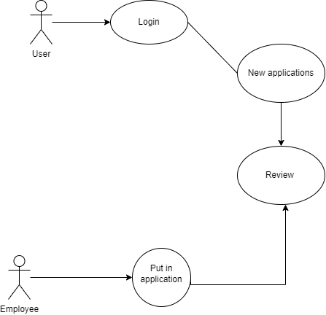

Class diagram:

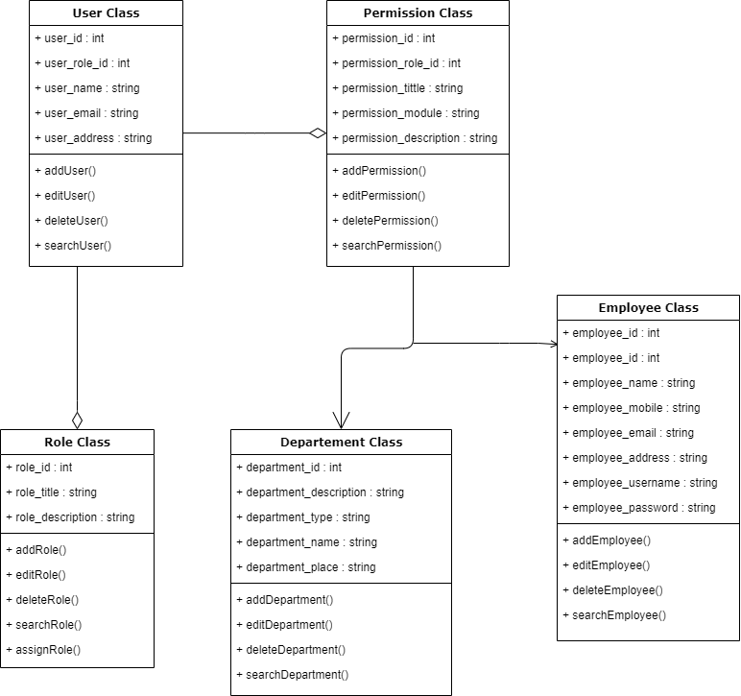

DataFlow diagram level 0

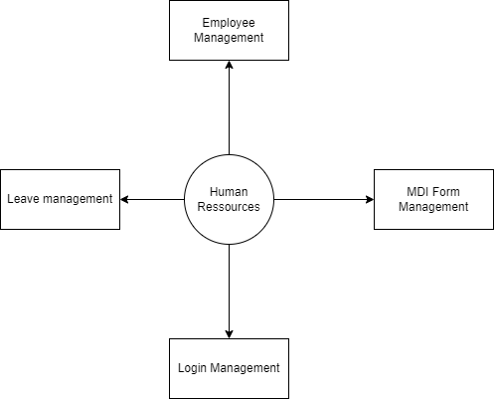

DataFlow Diagram 1st level

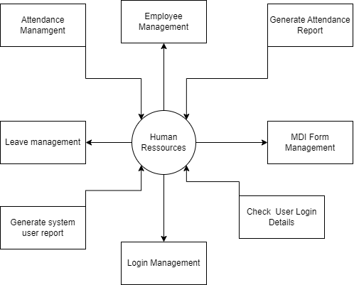

UML Diagram:

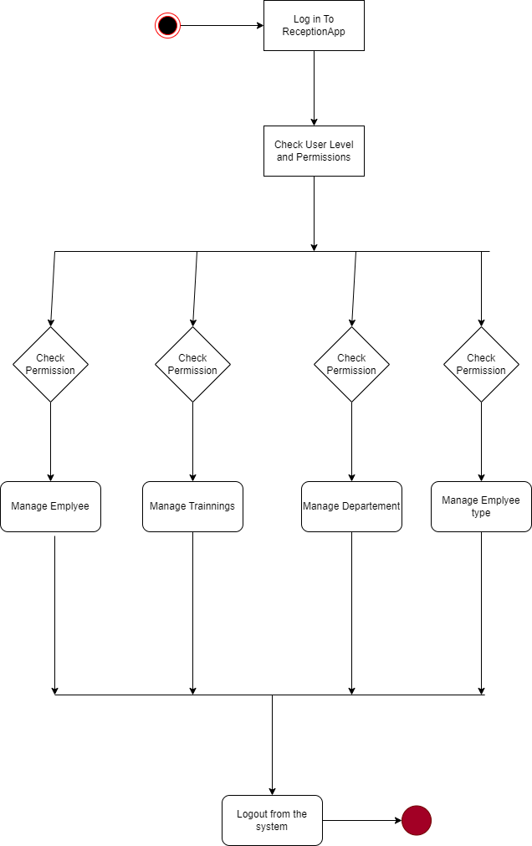

BPMN Diagram

